Week 1 – Day 1 Task

1. Product Exploration: KidCare (KidCare Point)

Value Proposition
KidCare (deployed as KidCare Point) simplifies the complex journey of modern pediatric parenting by offering an all-in-one digital health companion. It bridges the gap between parents and health services by consolidating fragmented health records, expert medical access, and childhood tracking metrics into a secure mobile platform. This eliminates guesswork and administrative friction, giving parents peace of mind and data-driven agency over their child’s development.

Core Features
- Seamless Appointment Management: Simple, structured digital booking with expert paediatricians and doctors.
- Interactive Vaccination Tracking: Automated timeline logging to track critical immunization windows precisely.
- Symptom Checker & Health Resources: On-demand informational utilities to assess mild paediatric issues early.
- Growth and Diet Logging: Direct data recording screens to monitor nutrition intake (meals) and map growth charts.
- Secure Multi-Format Messaging (Flips): Built-in encrypted text communication channels allowing parents to correspond safely with care partners.

Parent/Guardian User Flow (Staging Environment)
The user journey through the application operates across four modular phases:
[Profile & Kid Setup] ──> [Health Tracking Log] ──> [Care Coordination] ──> [Offline Support]
- Profile & Kid Setup: Secure login --> Create/edit parent profile --> Initialize child profile page (name, age, emergency details).
- Health Tracking Log: Navigate the dashboard to update growth details, upload physical medical history records (images/PDFs), or document recent meal types.
- Care Coordination: Use the booking engine to choose an open slot --> Generate a QR-coded appointment confirmation screen --> Send symptoms data directly to an expert doctor.
- Offline Support: Review cached local datasets—such as vaccination schedules or diet charts—even when disconnected from active networks.
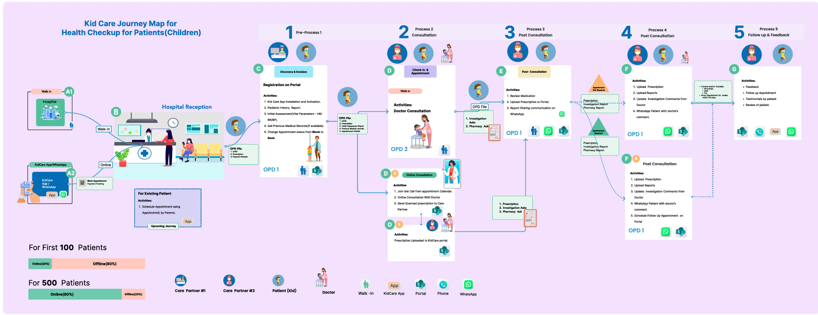

2. Industry Partner Analysis: Fennex

What Fennex Does ?
Fennex is an established industry provider specializing in AI-driven Health, Safety, Environment, and Quality (HSEQ) enterprise software built explicitly for high-risk, asset-intensive energy industries (such as offshore oil & gas extraction and wind energy generation). Their cloud architectures replace paper-based trails, static checklists, and legacy spreadsheets with cloud-native assurance software, real-time risk visibility, and automated compliance pipelines to mitigate major accident hazards on field sites.

Collaboration Context
366Pi Technologies serves as a strategic technology and integration partner for Fennex.
- Leadership & Strategy: Amitesh Anand has been a foundational pillar for both. His strategic and technical mentorship has been instrumental in linking the two firms, allowing Fennex to utilize 366Pi's technical delivery capabilities in cloud computing and data.
- Shared Innovation & Product Delivery: 366Pi Technologies functions as a key technical partner and outsourced innovation lab for Fennex, frequently collaborating to build and deliver digital solutions for the global energy and corporate sectors.
- Enterprise Focus: Together, the two entities have collaborated to implement bespoke, cloud-based applications (leveraging Azure, PowerBI, and mobile app ecosystems) designed for complex industrial environments and multinational drilling contractors

Fennex and 366Pi

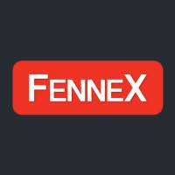

3. Core Infrastructure: SharePoint Basics
SharePoint acts as an enterprise-grade document management and team collaboration hub within modern digital workspaces, providing structural continuity across decentralized teams.

Key Capabilities
- Document Libraries: Controlled file repositories equipped with multi-user co-authoring, check-in/check-out mechanics, version history tracking, and structured metadata tagging.
- Communication & Team Sites: Broad intranet communication hubs designed to cascade corporate policy across an enterprise, alongside permission-locked Team Sites for project-specific sprint tracking.
- Automated Workflows: Native execution pipelines powered by Power Automate integration that trigger system alerts, conditional data routing, and validation routines when documents change state.

3 Enterprise Workflow Use Cases
- Automated Document and Contract Approval: An engineer uploads a project specification sheet to a document library; SharePoint parses the metadata and routes it down a multi-tier management chain for review and sign-off without manual email follow-ups.
- Centralized SOP & Policy Repositories: HR and legal departments house up-to-date Standard Operating Procedures (SOPs) or security protocols in a centralized directory, applying globally restricted read-only permissions for general staff while tracking edit history for auditors.
- Secure Vendor Data Rooms: Creating isolated, time-bound, external-facing folders within a site where external subcontractors can deposit deliverable assets securely without granting them lateral access to the parent corporation's wider cloud architecture.

4. Live Product Use Case Documentation

FloCard
- What problem it solves: Physical business cards generate immense paper waste, are easily lost, and fail to seamlessly integrate clean connection data into enterprise CRM engines.
- Who uses it: Enterprise sales departments, corporate networkers, business executives, and sustainability officers.
- What’s the core value delivered: Transforms contact exchange into a secure, blockchain-verified digital asset shared via QR or web links, enabling instantly synced, zero-waste business networking aligned directly with corporate Environmental, Social, and Governance (ESG) targets.

Tree Planters (Planters Module)
- What problem it solves: Corporate green initiatives and reforestation programs face transparency issues, making it difficult for corporate backers to confirm whether real trees were planted or if resources were mismanaged.
- Who uses it: Corporate Social Responsibility (CSR) teams, environmental project coordinators, and farm managers.
- What’s the core value delivered: Integrates seamlessly into the enterprise ecosystem to let coordinators tag, track, and locate trees or entire farm forests on an auditable digital ledger, converting abstract green pledges into verifiable environmental data points.

KidCare
- What problem it solves: Parents suffer from data fragmentation and high anxiety due to lack of visibility into pediatric timelines, while administrative teams struggle with disorganized medical records and booking management.
- Who uses it: Working parents, guardians, childcare coordinators, and pediatric care teams.
- What’s the core value delivered: Consolidates medical records, real-time tracking logs, and direct provider communication loops into a single interface, making childhood wellness management simple, organized, and reliable

